Project Activity 3 – Social Coding

Team Name: Dream Team

**Social Coding Selection**

Select the social coding application chosen by your team:

* Option 1: Feature enhancements of the Lab 4.9.2 code
* Option 2: New application – IPv4 / IPv6 Address Application

What were the reasons your team selected this option?

The reason why we choose Option 2, which is the IPv4 Address Application, because we found it interesting as we can determine specific details about our public IP address.

Describe your team’s application and its deliverables. What are the specific objectives of this application?

The application we’ve created we’re able to determine the public IP address of our devices and locate where it comes from including the geological information such as the latitude and longitude, the Autonomous System Number of the ISP, and the country code. This would provide helpful information in locating someone that committed crimes or another scenario.

Record your team member roles and skillsets

|  |  |
| --- | --- |
| Team member | Role / Knowledge / Skillset |
| Gerarman, Erika Marie G. | Team Leader, Team Management |
| Quebral, John Brian F. | Developer, Programming |
| Villote, Jerald D. | Secretary, Documentation |

**Strategy/Project Plan**

Provide a brief description of your team’s strategy for completing this project.

One of the team’s strategies for completing this project is determining what will be the best activity to accomplish. We decided to have one that we can be able to finish on time with the help of each other. Also, each of us has its own role that contributes to the team.

**Using GitHub for Collaboration**

What is the link to your GitHub repository?

|  |
| --- |
| https://github.com/Bryx28/IP-Address-Application.git |

Describe how GitHub was used to:

1. Create branches

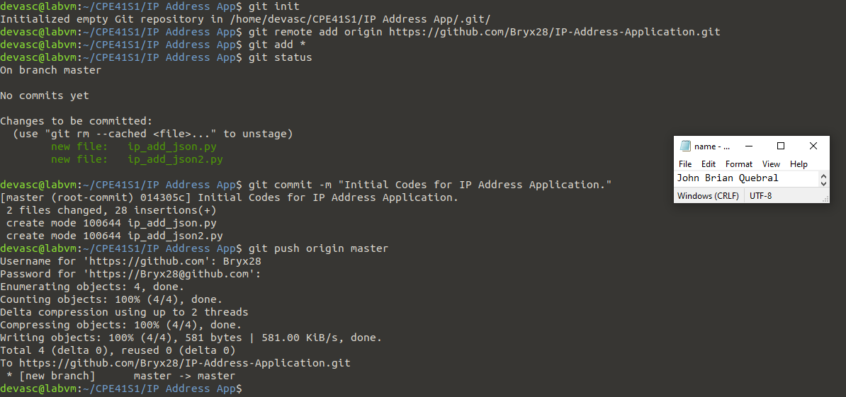Figure 1. Creating Master Branch

By creating branches, this will allow the team to create an identical copy of the original codebase, make changes, and then submit the changes to be merged back into the original codebase. The team can ensure that the final codebase is in a bug-free state by the use of these branches.

1. Add team members

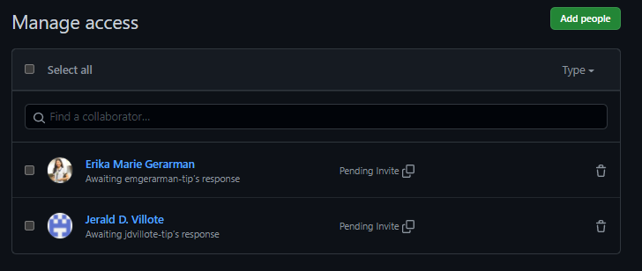

|  |
| --- |
| Figure 3. Adding People to the Repository    Figure 4.1. Accepting the Invitation    Figure 4.2. Accepting the Invitation  The GitHub was used to add team members in the repository by accessing the repository setting. Then, the main collaborator will manage its access and invite the collaborators. The role of the others would be accepting the invitation by the main collaborator. |

1. Do pull requests, code review, merge, etc.

|  |
| --- |
|  |
|  |

**Final Deliverables**

**Presentation**

Create a presentation about the project you selected. Your presentation should include:

* Information about your application, covering what features your team included.
* The reasons that your team decided on these specific features in your application
* Application code including comments and documentation. Your comments and documentation should be sufficient for any other team to be able to continue the project if required. Another team should be able to understand the application, your features and how to continue with the project.
* Demonstration of the application
* List of future enhancement (backlog)
* Reflection points – what issues have you faced while working on this activity, how did you find solutions, what have you learned.